在绘本故事教学中培养学生思维品质的实践
---以多维阅读第六级Big Dinosaur为例
成都市双流区棠湖小学（南区）夏瑞雪
【摘要】
绘本是小学英语教学的重要素材，也是培养学生思维品质的重要载体。在阅读过程中，教师应重视培养学生的思维能力，通过厘清故事脉络，采用图片环游，合作自读，两人讨论，角色扮演等形式，提高学生的阅读兴趣，促进其思维品质的有效提升。

【关键词】绘本教学；思维品质；阅读教学

- 引言
英语学科核心素养主要由语言能力、思维品质、文化意识和学习能力四方面构成（王蔷，2015）。其中思维品质包含多方面的内容，如观察、注意、记忆、分析、综合、概括、判断、推理、联想、解题、思辨、创新等。（朱智贤，2009）。绘本教学是培养学生思维品质的重要载体。教师应以故事脉络为主线，在拓宽学生阅读视野的同时，注重学生思维品质的培养。
本文将以《多维阅读系列》第6级中的绘本故事 Big Dinosaur为例，详述如何在绘本教学中培养学生的思维品质。故事发生在大恐龙与小恐龙之间。起初，小恐龙特别害怕大恐龙，在一块岩石下躲了起来。突然间，不远处的一座火山突然爆发，原本害怕的小恐龙鼓起勇气爬到大恐龙身上，用指尖轻轻敲醒了大恐龙，然而大恐龙见状却拔腿就跑，留下无助的小恐龙独自呆在岩石下。后来，大恐龙重回火中解救小恐龙。它们一同逃出火海，迎得新生。

故事文本如下：

二、教学实践与思考

1.读前环节
绘本教学的读前环节是阅读展开前的准备阶段，旨在激活学生的思维，引领学生进入阅读状态。教师可围绕故事主题设计读前活动，引入本课故事主角。同时，引导学生观察封面，细读图片，预测故事，形成期待。
（1）导入激趣，调动已知，激活学生的思维。
在绘本教学的读前环节，教师不仅要激发学生的阅读兴趣，更要激活其已有经验和知识储备，鼓励学生自主思考。
[教学片段1]
T: Today, we are going to read a story together. First, we are going to see some animals. If you know what the animal is, please stand up and say it aloud!
S1: butterfly/bird/rabbit/dog/dinosaur.
T: Look at all the animals, which one is the biggest?
S2: The dinosaur.
T: Yes. Today we are going to read a story about dinosaur.
以上教学片段中，教师通过设置头脑风暴游戏，学生们齐声抢答见到的动物剪影来说出其英文名称，并通过“Which one is the biggest?”这一问题，引出故事的主角---dinosaurs.
（2）观察图片，预测故事, 培养思维的发散性。
绘本读物的最大特点在于，书页包含生动形象的图片，以辅助学生理解文意。因此，阅读绘本的能力不仅仅体现在阅读文字的能力，还包含读图的能力。绘本封面往往揭示了故事发生的背景，并暗含寓意和信息。教师可带领学生观察图片，细读封面，鼓励其结合自身经验进行联想，培养思维的发散性。
[教学片段2]
T: Look at the cover page. （呈现图1）This is the title. Can you read it?
Ss: Big Dinosaur.
T: Now, look at this picture, what do you see?
S1: I see a dinosaur.
T: How many dinosaurs are there?
S2: Two.
T: Yes. This one is very big; we call it Big Dinosaur. This one is very small; we call it Little Dinosaur. What else can you see?
S3: A “fire mountain”!
T: Oh, it’s a volcano. So, where were they? Were they in a park or in a forest?
S4: They were in a forest.
T: Yes, they were in a forest. So when did the story happen? There were 2 dinosaurs; so, did it happen 5 years ago or many years ago?
S5: Many years ago maybe.
T: Look, there’s a volcano, let’s predict and guess: what would happen to them?
S6: They would run away!
S7: They would hide.
图1
导入故事后，教师带领学生细读封面，通过回答 “What can you see on the cover page?” “Where were they?” “ What would happen?” 等一系列问题，引导学生厘清故事背景信息。让学生怀着强烈的好奇心，带着疑问进入故事阅读。
2.读中环节
绘本教学的读中环节，是教师引导学生逐步理解文本，厘清故事脉络，提升阅读能力，培养思维品质的关键环节。
(1)深入细节，理清脉络，培养思维的逻辑性。
绘本故事的特点之一，在于故事情节或前后呼应，或充满悬念，或不时留白，或悄然转折，十分精妙。因此，教师应引导学生细读文本，理顺来龙去脉，挖掘故事中的悬念点、转折点、趣味点，以培养学生思维的逻辑性。
[教学片段1]
T: Look, what did the Little Dinosaur see?（呈现图2）
S1: He saw a big dinosaur.
T: Then, what did little dinosaur do? Listen.
S2: He went under the rock.
T: Why did he go under a rock?
S3:He was afraid of the Big Dinosaur.
T: Yes, Big Dinosaur was so fierce, the Little Dinosaur was scared of him.
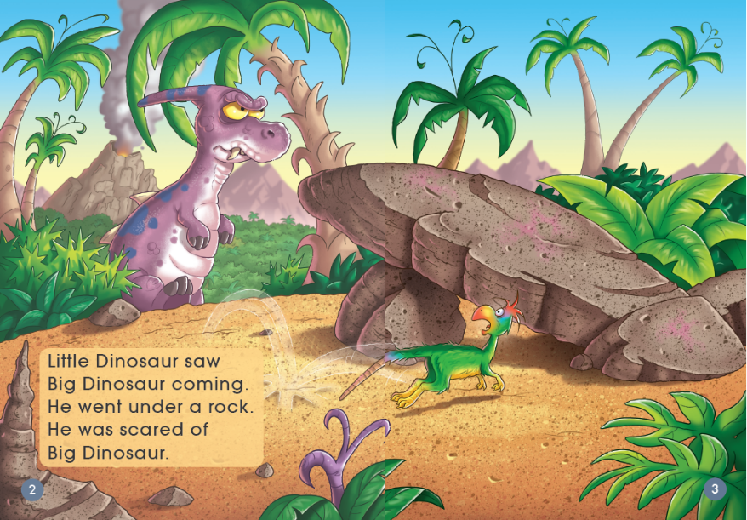
图2
该片段旨在引导学生体验Little Dinosaur的内心感受，让学生体会在森林里初遇时，两只恐龙的不同心情。而后，教师展示图片，并设问： Since they met each other, what would they say? 鼓励学生两人探讨，进行预测。有的学生假扮成大恐龙，十分凶狠地说，“I’ll eat you!”有的学生假扮小恐龙，可怜兮兮地说，“Oh, don’t kill me...I’m just a little dinosaur. 教学场面十分活跃，学生的阅读兴趣得以充分调动。
(2)运用场景，鼓励饰演，培养思维的迁移性。
[教学片段2]
T: Now, look at the Big Dinosaur, he had big teeth. (呈现图3)So, what did the Big Dinosaur do with his big teeth? Let’s listen and answer.
S1: His big teeth went crunch.
T: Yeah, His big teeth went crunch and down came a tree. So, what did little Dinosaur say? Maybe he said “I will have to...”
S2: Maybe he said “I’ll have to run”.
T: Let’s listen. Little Dinosaur said “I will have to stay here. I can't come out. Then, The Little Dinosaur stayed under the rock. Now, who wants to be Big Dinosaur and Little Dinosaur? Let’s act！

图3
该环节教师利用故事场景，巧设饰演活动，引导学生体验大恐龙畅快进食，而小恐龙却只能躲在岩石下，内心十分害怕的处境。通过体会此时故事人物的情绪，为后续故事情节的转折暗埋伏笔。
(3)抓住悬念，发起投票，培养思维的思辨性。
[教学片段3]
T: So, Big Dinosaur went crunch and ate all the leaves, then, what did Big Dinosaur do? （呈现图4）
S1: He went to sleep.
T: Yes, he went to sleep! But, look, suddenly, what happened? Wow! The volcano erupted! And a fire came! It was so dangerous! But look at the Big Dinosaur, he was still... sleeping! So, would Little Dinosaur wake Big Dinosaur up? Why or why not? Let’s guess and vote. If you think Little Dinosaur would wake Big Dinosaur up, hands up and say “Yes, because...”If you don’t think the Little Dinosaur would wake Big Dinosaur up, hands up and say “No, because...”
S2: I think Little Dinosaur would wake Big Dinosaur up because it was so dangerous, they would die.
S3: I don’t think Little Dinosaur would wake Big Dinosaur up because when Big Dinosaur woke up, he would eat Little Dinosaur.
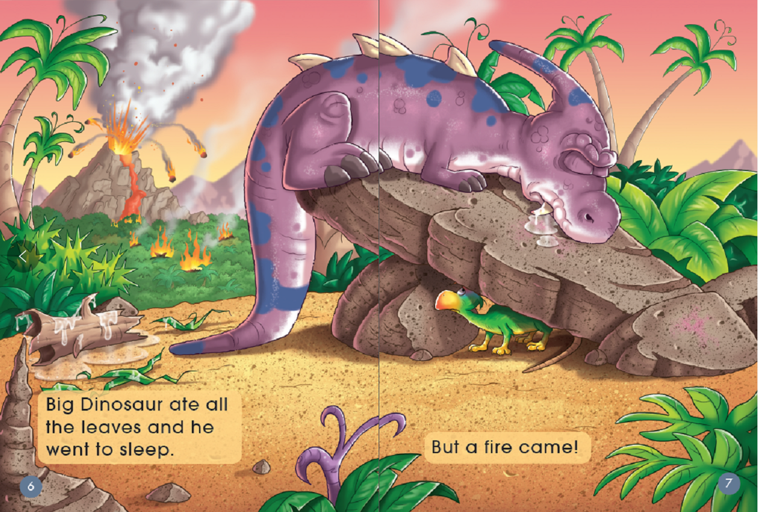
图4
远处的火山突然间喷发，大恐龙却依然还在熟睡中，它的处境十分危险。那么，柔弱而惊恐地小恐龙，会去叫醒大恐龙吗？教师抓住故事的设疑点，适时发起学生投票，引导其深入思考，发展思辨能力。
(4)深挖疑问，鼓励求证，培养思维的科学性。
[教学片段4]
T: So, what did Little Dinosaur do? Let’s listen and check.
S1: He went tap, tap on Big Dinosaur.
T: Oh, he went tap, tap on Big Dinosaur. Now, look at Big Dinosaur, did he wake up? Yes! Big Dinosaur woke up and saw fire coming. So, what would Big Dinosaur do? You can say “Big Dinosaur would...”
S2: Big Dinosaur would run.
T: Look, what did he do? （呈现图5）Oh! He ran away fast. And he said “I’m not staying here!”Then, look at Little Dinosaur, what did he say? Can you guess? Let’s listen. Oh, he said “I can’t run. The fire will get me.”so, why did Little Dinosaur say “I can’t run”? Let’s discuss in 4 and answer.
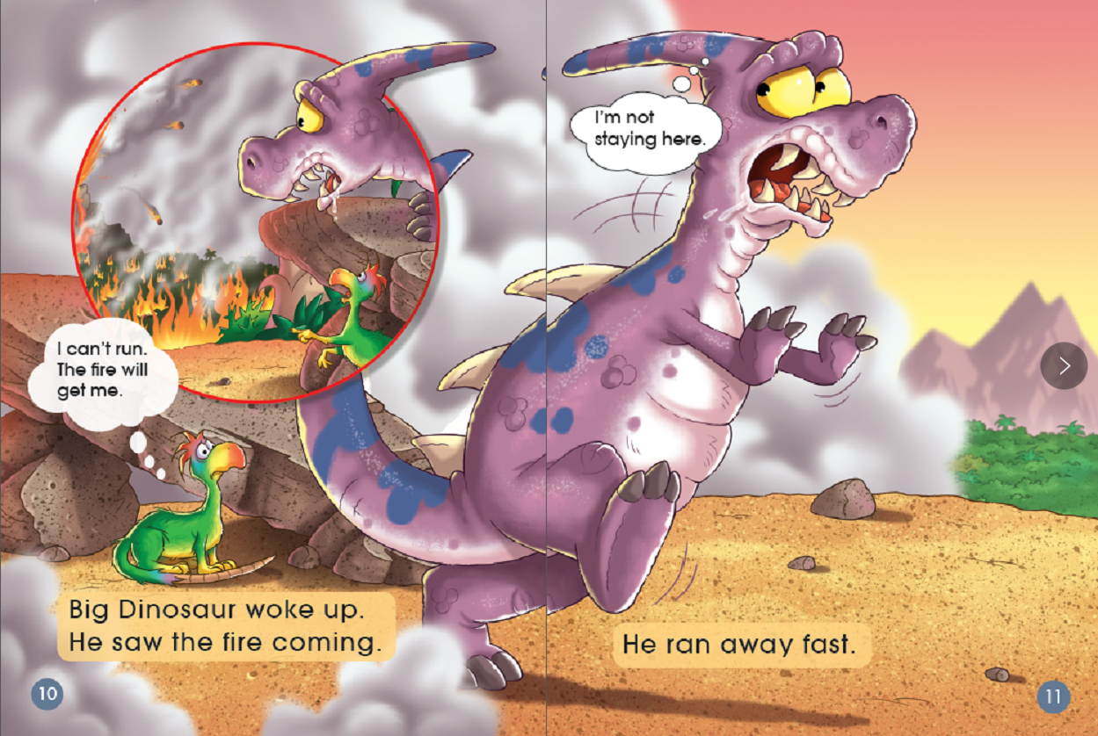
图5
大火已经蔓延，小恐龙却说 “I can’t run. The fire will get me.” 教师及时抓住这一疑问，鼓励学生进行分组讨论：探索在山火蔓延的情形下，小恐龙说他不能跑的原因，以及在面临该险境时的正确做法。该讨论活动提供了更为真实的语境，学生各抒己见，共同探索，促进科学思维的萌发。
3.读后环节
就绘本教学而言，教师应充分关注读后阶段问题的设计。在解答问题的过程中，引导学生对故事进行深入分析，以加深对故事含义的理解，促进其思维深刻性和思辨性的有效提升。
（1）关注体验，升华情感，提升思维的深刻性。
[教学片段1]
T: I still have a question for you. There was fire everywhere, and it’s really dangerous. Why did Big Dinosaur come back and save Little Dinosaur?
S1: Because Little Dinosaur saved Big Dinosaur first.
S2: Because they are friends.
T: I like your ideas. Maybe at first, Little Dinosaur was scared of Big Dinosaur, but he saved Big Dinosaur when the fire came. So, Big Dinosaur was touched and save him too. They helped each other. Love and kindness passed on between them. Then, they were safe at last.
阅读绘本之后，教师还应引导学生多角度理解故事所包含的意义，及其传递的情感态度。设置发散性的问题，推动学生对故事的深层理解。在充分体现学科育人性的同时，提升学生思维的深刻性。
（2）鼓励表达，尊重差异，深化思维的思辨性。
T: If you were Big Dinosaur, What would you do? Would you go back and save little Dinosaur?
S1: I would go back and save little Dinosaur because we are dinosaurs.
S2: Maybe I would run away because it’s very dangerous.
S3: I think I wouldn’t go back. I would jump into the river.
S4: Maybe I wouldn’t go back either because my mom would worry about me.
T: Your ideas sound reasonable. Before you save someone, make sure you are safe. Then we can help each other and pass on the kindness.

小学阶段的儿童虽年龄尚小，经验不足。但也具备了一定的思辨能力。教师应引导学生深入分析，鼓励学生对故事中的情节发表自己的辩证观点。在培养其思辨思维的同时，帮助其形成正确的情感态度和价值观。

三、结束语
绘本教学是培养学生思维品质的重要载体。教师应深入解读故事文本，充分利用故事情节、图片资源、故事寓意等，在关注阅读能力的同时，促进学生思维品质的有效提升。

参考文献
王蔷.2015.从综合语言运用能力到英语学科核心素养---高中英语课程改革的新挑战 [J]. 英语教师, (16)：6-7.
朱智贤.2009.儿童心理学[M].北京：人民教育出版社.
外语教学与研究出版社.2018.多维阅读系列.第四级Big Dinosaur [M].外语教学与研究出版社.

